CSIT314 Software Development Methodologies - Group Project

Sprint 4 - US33: Save IDP
Interior Design Platform - Customer
All diagrams were drawn in draw.io. Open "US33 Save IDP.drawio" in this folder to edit them - each diagram is its own page in that file. The exported images are in the "diagrams" folder.

Assumptions
- The system is the Interior Design Platform from the project specification. Sprint 4 covers the Interior Designer's past IDP stories (US25 - US29) and the Customer's saved list stories (US33 - US35).
- We follow B-C-E: the actor only talks to the boundary (page), the boundary only talks to the controller, and the controller works with the entity classes. There is one controller per use case.
- Who checks what: the boundary checks all the input (required fields, lengths, formats, e.g. not suspending your own profile) and trims spaces, then passes an entity object on. The controller just calls the entity and returns the result. The entity checks for duplicates and the database state (e.g. name already used, only Active rows are changed), then saves. In US33 there is no typed input: the page takes the idpId from the URL and the customerId from the session. SaveIDPController.saveIDP(customerId, idpId) just calls SavedIDP.createSavedRecord(customerId, idpId) and returns saved. The entity refuses a duplicate and an IDP customers can no longer see.
- Being logged in as a Customer (UC30) is the precondition, so the page and the diagrams don't check the customer again (no CustomerLoginController). customerLoginRequired in app.py only sends someone with no session to /customer/login. The customerId is always session["userId"], never a value from the page.
- The Save IDP button is on the US32 View IDP page and is always shown - the button has no "Saved" state. US33 handles an IDP that is already saved.
- There is no separate "is it already saved?" check before saving. SavedIDP.createSavedRecord(customerId, idpId) only inserts the saved_idp row when the IDP is Active and its category is Active, and UNIQUE(customerId, idpId) stops a duplicate. It returns saved = True when a row was added, otherwise False.
- Both results go back to the IDP's page with a message: saved → "IDP saved to your saved list" (MSG_SAVED); not saved → "This IDP is already in your saved list or is no longer available" (MSG_NOT_SAVED). The redirect is HTTP 302 to /customer/idps/<idpId>?saved=1, and US32 doesn't count that reload as a view, so the view statistics (US37) only count real visits.
- Current and Past IDPs can both be saved. A saved IDP is listed on the Saved IDPs page (US35) and can be searched there (US34). There is no remove / unsave.

1. User story
Story ID | US33
User story | As a customer, I want to save an IDP so that I can look at it again later.
Actor | Customer
Priority | Medium
Story points (estimate) | 2
Acceptance criteria | 1. Given I am logged in as a customer and viewing an IDP, when I click "Save IDP", then the IDP is added to my saved list and I see "IDP saved to your saved list".  2. Given the IDP is already in my saved list, when I click "Save IDP" again, then no duplicate is added and I see "This IDP is already in your saved list or is no longer available".  3. Given the IDP was deleted or its category was suspended after I opened it, when I click "Save IDP", then nothing is saved and I see the same message.  4. After clicking Save I am back on the same IDP page, the Save IDP button is still shown, and this reload doesn't count as a view.  5. A saved IDP appears in my Saved IDPs list (US35).  6. Given I am not logged in, when I try to save an IDP, then I am sent to the customer login page.
Tasks | #192 Draw Use Case Diagram and Write Use Case Description  #200 Draw BCE and Sequence Class Diagram  #208 Implement the Save IDP function to allow customers to add projects to their saved list.  #252 Design Wireframe  #257 Write and Execute Test Cases

2. Use case diagram
The user story becomes one use case, UC33 Save IDP. The Customer is the only actor. Being logged in (UC30) is the precondition; the Save IDP button is on the View IDP page (UC32), and the saved list is viewed in UC35 and searched in UC34.
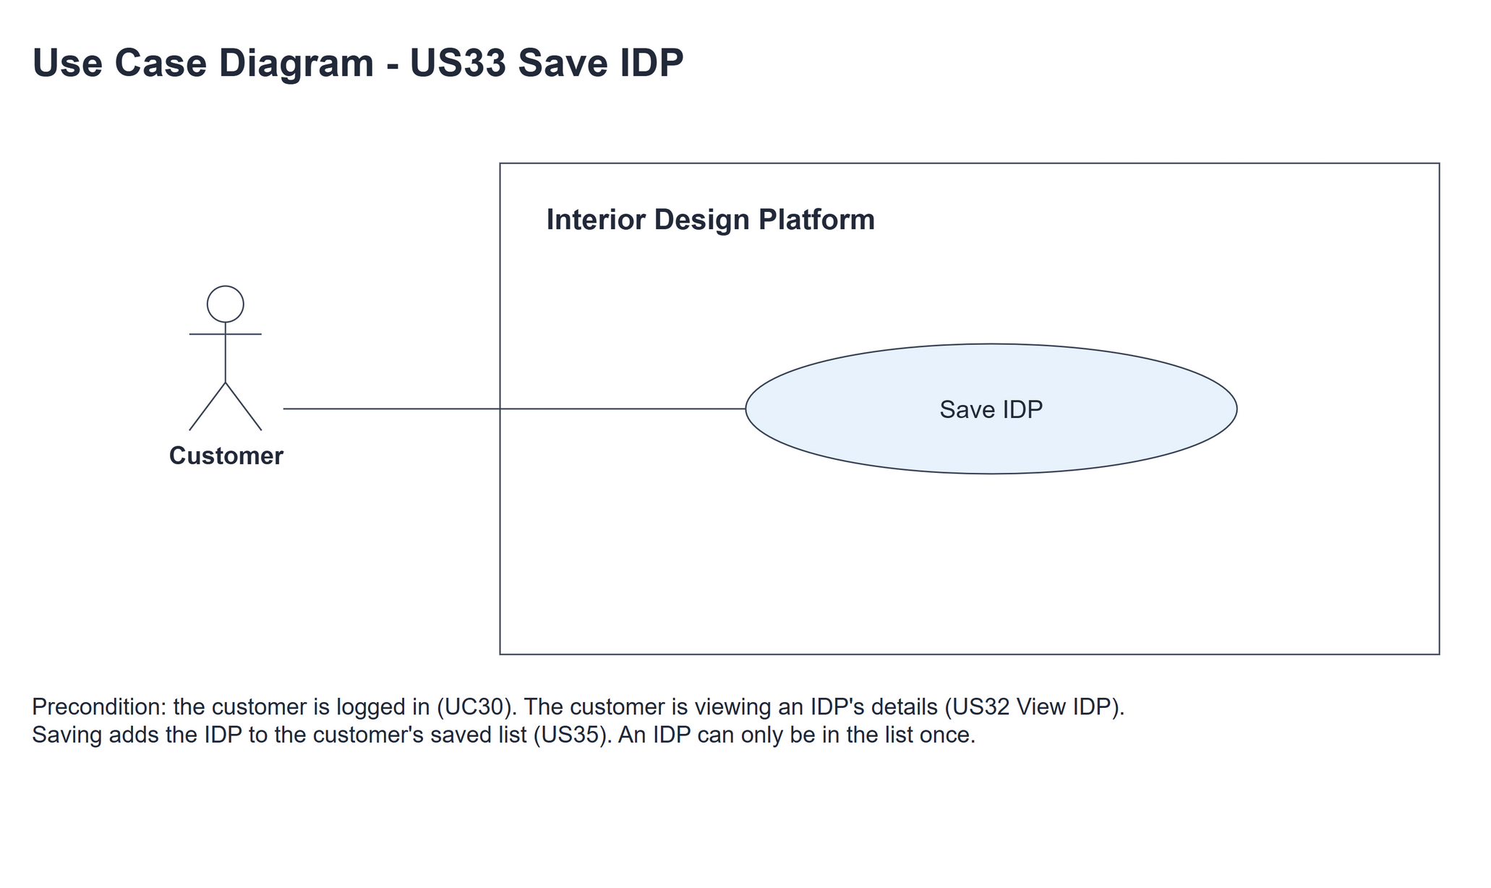
Figure 1: Use case diagram for US33 Save IDP

3. Use case description
Use case | UC33 Save IDP
Actor | Customer
Brief description | The Customer saves an IDP to their saved list so they can look at it again later.
User story | US33: As a customer, I want to save an IDP so that I can look at it again later.
Preconditions | The Customer is logged in (UC30) and is viewing an IDP's details (UC32).
Trigger | The Customer clicks "Save IDP" on the IDP details page.
Basic flow | 1. The Customer clicks "Save IDP" on an IDP's details page.  2. The system passes the IDP and the logged-in Customer on to be saved.  3. The system adds the IDP to the Customer's saved list. It only adds it when it isn't in the list yet and customers can still see it (the IDP and its category are Active), and reports whether it was saved.  4. The IDP was saved: the system shows "IDP saved to your saved list".  5. The system takes the Customer back to the same IDP page (/customer/idps/<idpId>?saved=1). This reload isn't counted as a view, and the Save IDP button is still shown.
Alternative flows | 3a. The IDP is already in the Customer's saved list, or it was deleted or its category was suspended: nothing is added. At step 4 the system shows "This IDP is already in your saved list or is no longer available" instead, then continues at step 5.
Postconditions | The IDP is in the Customer's saved list once (shown in UC35), or nothing changed and the message is shown. The reload after Save is not counted as a view.

4. Wireframes
The wireframes were drawn in draw.io. They are low-fidelity: they show the layout and the flow, not the final colours. They follow customerBase.html, customerViewIDP.html and static/style.css. The Save IDP button is always shown on the IDP details page.

4a - Save IDP button on the IDP details
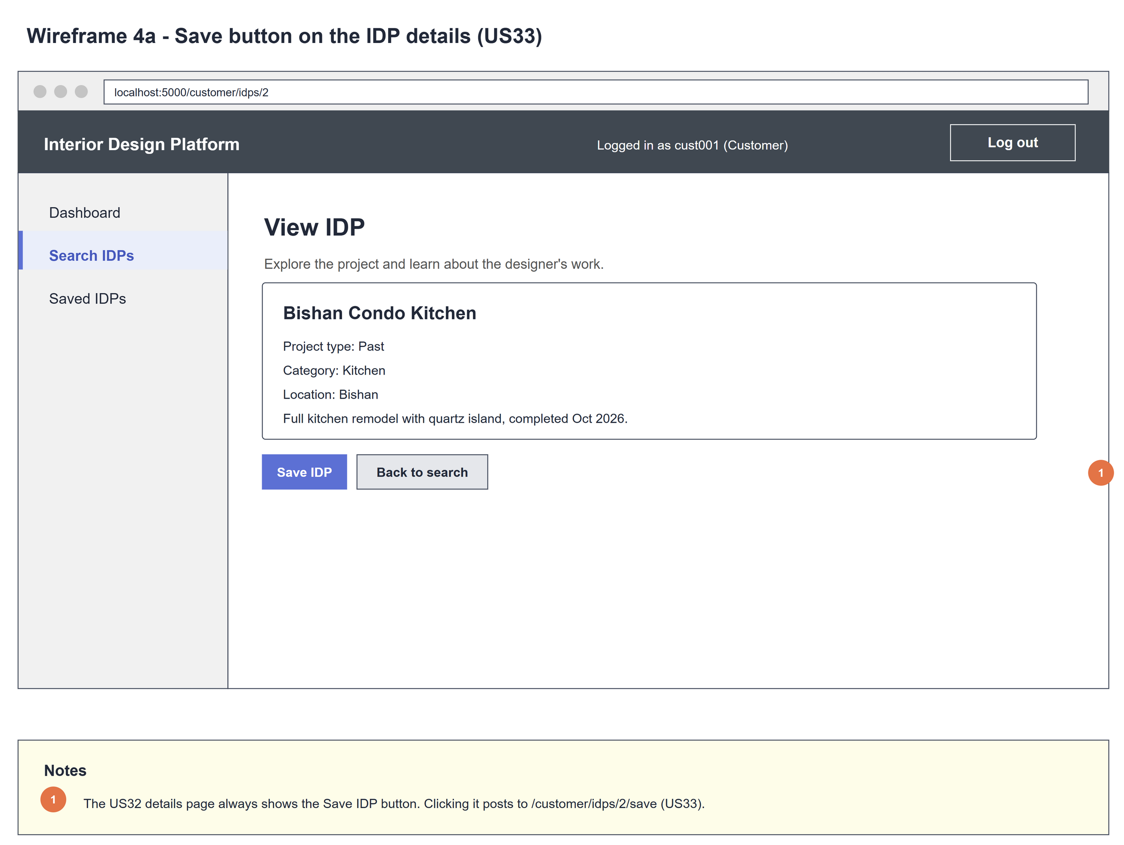
Figure 2: Wireframe 4a - Save button (US33)

4b - IDP saved
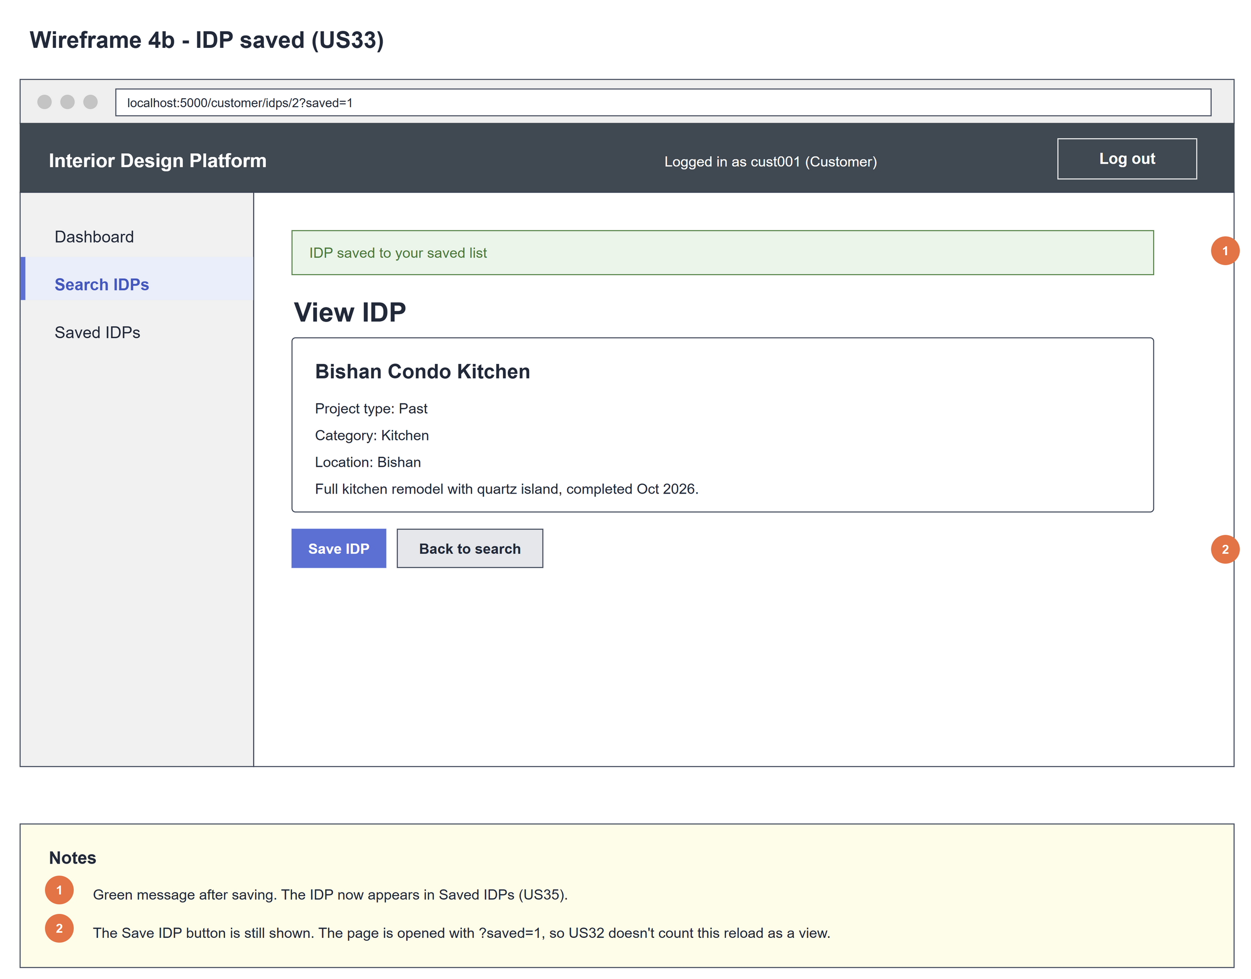
Figure 3: Wireframe 4b - IDP saved (US33)

4c - Already saved or no longer available
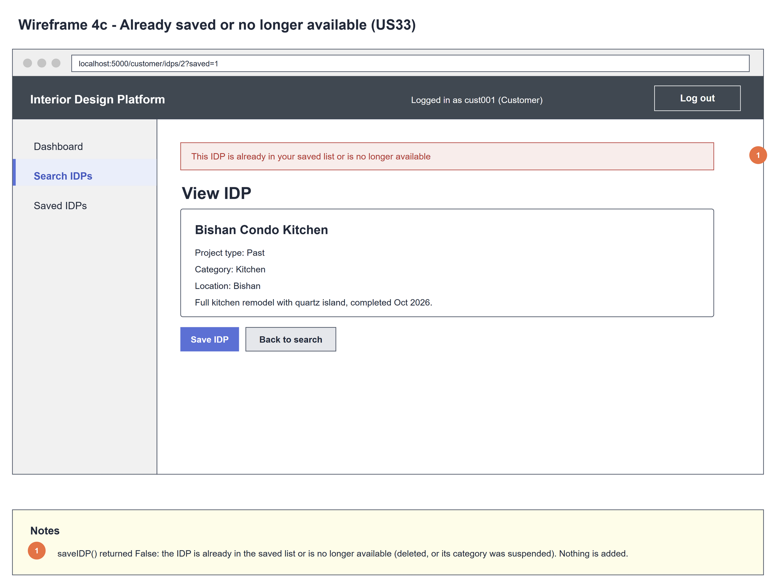
Figure 4: Wireframe 4c - Already saved or no longer available (US33)

5. B-C-E class diagram
The solid line means the boundary calls the controller. The dashed line means the controller uses the entity class. Only the operations needed for this use case are shown, with the same names as the code.
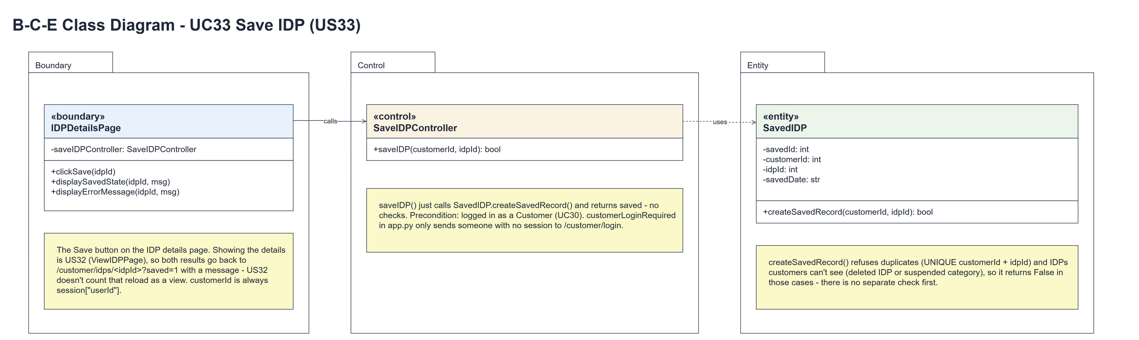
Figure 5: B-C-E class diagram for US33 Save IDP
Layer | Class | What it does
Boundary | IDPDetailsPage | The Save IDP button on the US32 details page (ViewIDPPage). clickSave(idpId) calls saveIDP(customerId, idpId) with customerId = session["userId"], then displaySavedState(idpId, MSG_SAVED) when saved is True or displayErrorMessage(idpId, MSG_NOT_SAVED) when it is False. Both redirect (HTTP 302) to /customer/idps/<idpId>?saved=1.
Control | SaveIDPController | Controller for UC33. saveIDP(customerId, idpId) just calls SavedIDP.createSavedRecord(customerId, idpId) and returns saved - no checks.
Entity | SavedIDP | The only entity (one row = one IDP in one customer's saved list). createSavedRecord(customerId, idpId) inserts the row only when the IDP and its category are Active; UNIQUE(customerId, idpId) stops duplicates. Returns True if a row was added, otherwise False.

6. Sequence diagram
The sequence diagram follows UC33. The page calls the controller with the logged-in customer's id and the IDP (step 2), and the controller makes one call to SavedIDP.createSavedRecord(customerId, idpId) (step 3), which returns saved (steps 4-5). There is no check before saving - the entity refuses a duplicate or an IDP customers can't see. The alt shows the two endings: MSG_SAVED, or MSG_NOT_SAVED (alternative flow 3a). Both send the Customer back to /customer/idps/<idpId>?saved=1, which US32 shows without counting a view. Saving has no typed input, so there is no [input is valid] alt.
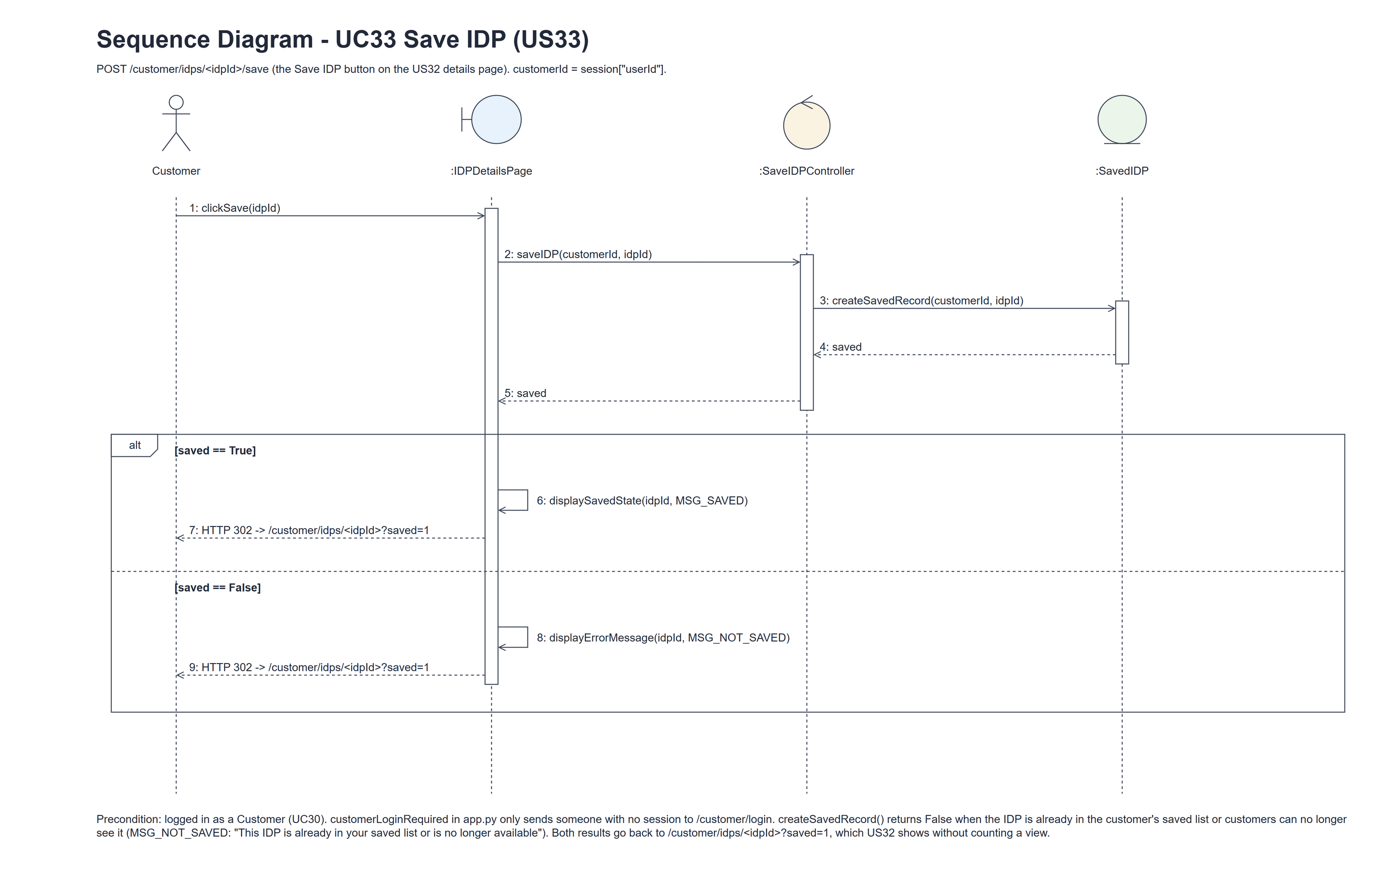
Figure 6: Sequence diagram for UC33 Save IDP

7. Test cases
Test data used below (same as the test file): an interior designer with Active Current and Past IDPs, a Suspended IDP, an IDP in a Suspended category, and the customer cust001 / Cust@123. Tests use an isolated database.

7a. System test cases (black box)
Equivalence partitioning and boundary value analysis were used to pick the test data. Fill in "Actual result" and "Pass/Fail" after running each test.
Test ID | Scenario | Prerequisites | Test steps | Test data | Expected result | Actual result | Pass / Fail
TC33.1 | Save an IDP | Customer logged in; IDP not saved yet. | Open the IDP; click Save IDP. | Visible Current IDP | "IDP saved to your saved list"; the IDP is listed in Saved IDPs (US35).
TC33.2 | Save a Past IDP | Customer logged in. | Open a Past IDP; click Save IDP. | Visible Past IDP | Saved; listed in Saved IDPs.
TC33.3 | Save the same IDP twice | The IDP is already in the saved list. | Click Save IDP again. | Saved IDP | "This IDP is already in your saved list or is no longer available"; still only one entry in Saved IDPs. | "This IDP is already in your saved list or is no longer available" was shown. Saved IDPs still listed the IDP once. | Pass
TC33.4 | IDP no longer available | Open the IDP, then the designer deletes it (or its category is suspended). | Click Save IDP. | Suspended IDP; Suspended category | "This IDP is already in your saved list or is no longer available"; nothing saved. | The same message was shown for the deleted IDP and for the IDP in the suspended category. Nothing was saved. | Pass
TC33.5 | Back on the IDP page | Customer logged in. | Click Save IDP. | Visible IDP | Back on /customer/idps/<idpId>?saved=1 with the message; the Save IDP button is still shown. | Back on /customer/idps/<idpId>?saved=1 with "IDP saved to your saved list". The Save IDP button was still shown. | Pass
TC33.6 | Save doesn't count a view | Customer logged in. | Open an IDP, click Save IDP, check the designer's view statistics (US37). | Visible IDP | Opening the IDP counts one view; the page shown after Save adds none. | Opening the IDP counted one view. The page shown after Save added none (still 1). | Pass
TC33.7 | Not logged in | Signed out. | POST /customer/idps/<idpId>/save. | No session | Sent to the customer login page; nothing saved.
TC33.8 | Only my saved list | Two customers. | cust001 saves an IDP; the other customer opens Saved IDPs. | Two customers | The IDP is only in cust001's saved list.

7b. Unit test cases (for TDD)
These are written before the code (test-driven development) and run automatically in the CI pipeline. They cover normal inputs, abnormal inputs and boundary values. Each one matches a test function in tests/test_us33_saveIDP.py (UT33.1 is test_ut33_1_...). Controller means SaveIDPController; Boundary means IDPDetailsPage. "Pass" is from the pytest run on 10 November 2026.
Test ID | Class and method | Input / setup | Expected output | Type | Pass / Fail
UT33.1 | SavedIDP.createSavedRecord() | Visible Current IDP, not saved yet. | True; exactly one saved_idp row for (customerId, idpId), counted in the table. | Normal | Pass
UT33.2 | SavedIDP.createSavedRecord() | The same IDP saved twice. | The second call returns False; still one row (UNIQUE customerId + idpId). | Abnormal | Pass
UT33.3 | SavedIDP.createSavedRecord() | Suspended IDP, IDP in a Suspended category, missing ID 999999. | False; no row added. | Abnormal | Pass
UT33.4 | SavedIDP.createSavedRecord() | Visible Past IDP. | True - Past IDPs can be saved too. | Normal | Pass
UT33.5 | Controller.saveIDP() | Visible IDP, not saved yet. | True - the entity's result is returned unchanged (one createSavedRecord call, nothing else). | Normal | Pass
UT33.6 | US32 page (Save IDP button) | GET /customer/idps/<idpId>. | The Save IDP form posts to /customer/idps/<idpId>/save. | Normal | Pass
UT33.7 | Boundary.clickSave() | POST save for a visible IDP and follow the redirect. | MSG_SAVED shown; the Save IDP button is still shown; one saved_idp row. | Normal | Pass
UT33.8 | Boundary.clickSave() | POST save twice for the same IDP. | The second shows MSG_NOT_SAVED (flash "error"); still one row. | Abnormal | Pass
UT33.9 | Boundary.clickSave() | POST save for a Suspended IDP. | HTTP 302; flash ("error", MSG_NOT_SAVED); no row added. | Abnormal | Pass
UT33.10 | customerLoginRequired (app.py) | POST save, not logged in. | Redirects to /customer/login. | Abnormal | Pass
UT33.11 | Controller.saveIDP() | The same IDP saved twice. | The second call returns False straight from createSavedRecord; the page then shows MSG_NOT_SAVED. | Abnormal | Pass
UT33.12 | Boundary.clickSave() | POST save for a new IDP, then for the same IDP again. | Both responses are HTTP 302 to /customer/idps/<idpId>?saved=1. | Normal | Pass
UT33.13 | Boundary.clickSave() + US32 page | POST save and follow the redirect; count idp_view rows. | No idp_view row is added (the ?saved=1 reload isn't counted as a view). | Boundary | Pass
UT33.14 | Boundary.clickSave() | SaveIDPController stubbed. | Only saveIDP(customerId, idpId) is called, once, with customerId = session userId - no checkAlreadySaved() call before it. | Normal | Pass

